Timer Modes:
Timer_A supports 4 modes of operation:
- Stop Mode: In this mode the Timer is Halted.
- Up Mode: Timer repeatedly counts from Zero to value stored in Capture/Compare Register 0 (TACCR0).
- Continuous: Timer repeatedly counts from Zero to 0xFFFF, which is maximum value for 16-bit TAR.
- Up/Down Mode: Timer repeatedly counts from Zero up to the value in TACCR0 and back down to zero.
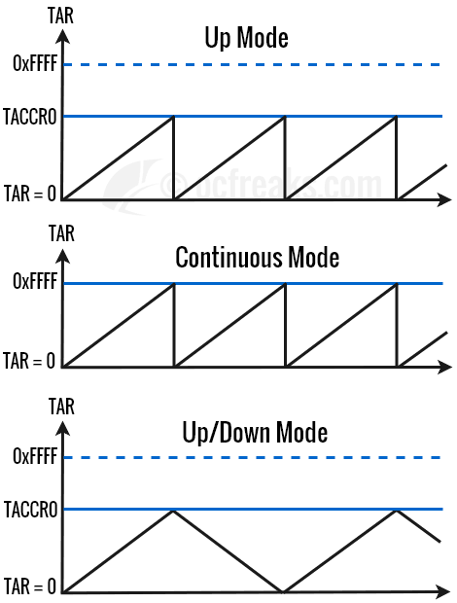

MSP430 Timer Registers
1) TAR – Timer Counter Register: Holds the current count for Timer_A.
2) TACCRx – Timer Capture/Compare Register: In Compare mode, it holds compare value to be compared against TAR. In Capture mode, it holds the current v alue of TAR when a capture is performed. Maximum value it can store is 0xFFFF since its a 16 bit register.
3) TACTL – Control Register: Used to configure Timer_A. This register is divided as follows:
- Bit[0] – TAIFG – Timer_A Interrupt Flag. 0 = No interrupt pending, 1 = Interrupt pending.
- Bit[1] – TAIE – Timer_A Interrupt Enable. 0 = Interrupt Disabled, 1 = Interrupt Enabled.
- Bit[2] – TACLR – Timer_A clear. Setting this bit resets TAR, clock divider, and the count direction. It is automatically reset and is always read as zero.
- Bits[5:4] – MCx – Mode Control bits. Used to select between 4 different modes as given:
[00] = MC_0 – Stop mode: Timer is halted.
[01] = MC_1 – Up mode: Timer counts up to TACCR0.
[10] = MC_2 – Continuous mode: Timer counts up to 0xFFFF.
[11] = MC_3 – Up/down mode: Timer counts up to TACCR0 then down to 0x0000.
- Bit[7:6] – IDx – Input divider. Selects input clock divider.
[00] = ID_0 – /1
[01] = ID_1 – /2
[10] = ID_2 – /4
[11] = ID_3 – /8
- Bits[9:8] TASSELx – Timer_A clock source select.
[00] = TASSEL_0 – TACLK
[01] = TASSEL_1 – ACLK
[10] = TASSEL_2 – SMCLK
[11] = TASSEL_3 – INCLK (check datasheet)
- Other Bits – Reserved
3) TACCTLx – Capture/Compare Control Register: Used to configure capture/compare options. I will only cover the parts of this register which are applicable to this tutorial. We will see it in detail in other tutorials(for Capture mode & PWM).
- Bit[0] – CCIFG – Capture/compare interrupt flag: 0 = interrupt pending, 1 = Interrupt pending.
- Bit[4] – CCIE – Capture/compare interrupt enable: This bit enables the interrupt request of the corresponding CCIFG flag. 0 = Interrupt disabled = 1 Interrupt enabled.
- Bit[8] – CAP – Capture mode: Used to select between Compare and Capture mode. We will this bit in its default setting i.e. = 0. 0 = Compare mode, 1 = Capture mode.
4) TAIV – Interrupt Vector Register: Used to identify the flag which requested an interrupt. This is a read only register and only uses 3 bits [3:1] called TAIVx. The values for TAIVx which corresponds to various sources is as given below:
- 0x00 = No Interrupt Pending.
- 0x02 = Capture/Compare 1 – TACCR1 CCIFG.
- 0x04 = Capture/Compare 2 – TACCR2 CCIFG.
- 0x0A = Timer(TAR) Overflow – TAIFG.
- Other – Reserved.

Note:

Timer Register Naming Convention: Using the register names as given in user manual will default to Timer0_A3 registers. For e.g. TACTL is same as TA0CTL. Note that Timer registers are defined as TAnCTL, TAnCCR0 and so on.. where n = Timer module number(in our case 0 or 1). For Timer1_A3 these names will be TA1CTL, TA1CCR0 and so on. TA0CTL and other Timer0_A3 are just redefined as TACTL, TACCR0 and so on.

Configuring & Setting Up Timer in MSP430
Given, clocks are configured properly, basic setup of Timer_A can be done follows:
- Set the Compare value in TACCR0 if using Up mode or Up/Down mode. Timer may be stopped by using TACCR0 = 0; and can be started/restarted any time by writing a non-zero compare value in TACCR0 whenever Timer is to be used. Total Counts by timer will be TACCR0 + 1.
- Set CCIE(Capture/Counter Interrupt Enable) bit in TACCTL0 to enable interrupt for CCR0. We also keep the CAP bit to default value(=0) to enable Compare mode.
- Select Clock Source, Input Clock divider and Timer mode using TASSELx, IDx, MCx fields respectively.
- Enable global Interrupts and we are done.
Note:
TACCR0 has dedicated interrupt vector. Other TACCRx have common interrupt vector(see TAIVx and section 12.2.6 on page 367 in User Manual).

In examples given below we will use Up mode with input clock source as SMCLK(MCx = MC_1) without an divider(IDx = ID_0 i.e. divide by 1). We will set MCLK and SMCLK to run at 1MHz, both sourcing clock from DCO.

Handy MSP430 Timer Formula for delay calculations
Formula for amount of time taken to increment TAR count by 1 is given as:
Resolution(Delay per TAR Count) in Seconds = DIV/Input Clock in Hz
where DIV = Input Clock divider either 1,2,4 or 8.
E.g.: When using divider of /2 and Input clock of 4MHz we get timer resolution as,
Resolution = 2/4 x 10⁶HzSeconds = 0.5 x 10⁻⁶ Seconds = 0.5 µS
The time required for TAR to count from 0 and reach TACCR0 (i.e. overflow or TAR period) is given as:
Timer Period in Seconds = DIV x (TACCR0 + 1)/Input Clock in Hz
We subtract 1 from TACCR0 since TAR counts “TACCR0+1” times to overflow. This is because count starts from 0.
E.g.: When using divider of /2, Input clock of 4MHz and TACCR0 = 1000-1 = 999, we get Timer Period as,
Timer Period = 2 x (999 + 1)/4 x 10⁶Hz= 0.5 x 1000 x 10⁻⁶ S = 500 µS

